- Do not edit/delete any heading or section with red text.
- Type /paste you answers in relevant sections (below Final Answer (in all questions , Approach (wherever required ) and Charts & tables (wherever required)) of the solution
- Link to submission guidelines
- Please note that submission not following the guidelines will not be accepted

OBJECTIVE QUESTIONS

Question 1: What is the total no. of attributes present in the data?

Solution:

Final Answer (if any):
The dataset contains 16 attributes in total:
- 10 attributes in the Tickets sheet
- 6 attributes in the IT Agents sheet

Approach (if any):

The total number of attributes was calculated by counting all columns available across both datasets after data preparation. The Tickets sheet contains ticket-related information, while the IT Agents sheet contains agent information. The helper column "Agent Name" created during data cleaning was also included as an attribute.

Charts & Tables (if any):

Question 2: Which columns have inconsistent or missing values, and what is the count of such values?

Solution:

Final Answer (if any):

No missing values were identified in the dataset. However, the following data inconsistencies were found:

Column Missing Values Inconsistencies Count
Severity 0 "Unclasified" typo 356
Severity 0 "Mayor" typo 6228
Priority 0 "Unassiged" typo 29410

These inconsistencies were corrected during the data cleaning process to ensure data quality and accurate analysis.

Approach (if any):

Data quality checks were performed using filters, conditional formatting, and counting functions to identify blank or inconsistent records. Each column was reviewed to determine the number of missing or invalid values present in the dataset.

- =COUNTBLANK(A2:A) to count the missing values/blank cells
- Use a filter to find the inconsistencies in each column.
Charts & Tables (if any):

Question 3: What is the average daily ticket volume over time?

Solution:

Final Answer (if any):
The average daily ticket volume is 53.37 tickets per day. This indicates that the IT support team handles approximately 53 tickets on an average day, reflecting a consistently active support environment throughout the analysis period.

Approach (if any):
The ticket creation date field (Fecha) was used to group tickets by day. A pivot table was created with Date as Rows and Count of Ticket ID as Values. The average of the daily ticket counts was then calculated to determine the average daily ticket volume over time.

Charts & Tables (if any):
Daily Ticket Volume
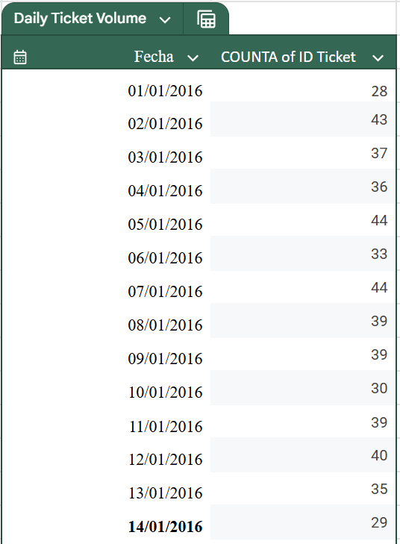
Description:
Displays the number of tickets generated per day and helps evaluate Average daily ticket volume.

Question 4: What is the distribution of ticket categories (e.g., Login Access, System, Software)?

Solution:

Final Answer (if any):
The distribution of ticket categories is as follows:

Request Category | COUNTA of ID Ticket | Percentage
Hardware | 9733 | 9.982768877
Login Access | 29193 | 29.94215266
Software | 19570 | 20.07220661
System | 39002 | 40.00287185
System-related requests represent the largest share of tickets, while Hardware requests account for the smallest proportion.

Approach (if any):
A pivot table was created using Request Category as Rows and Count of Ticket ID as Values. Percentage contribution was then calculated by dividing each category count by the total number of tickets. This helped identify the distribution of requests across different IT support categories.

Charts & Tables (if any):
- Table / Chart Name:
Category Distribution
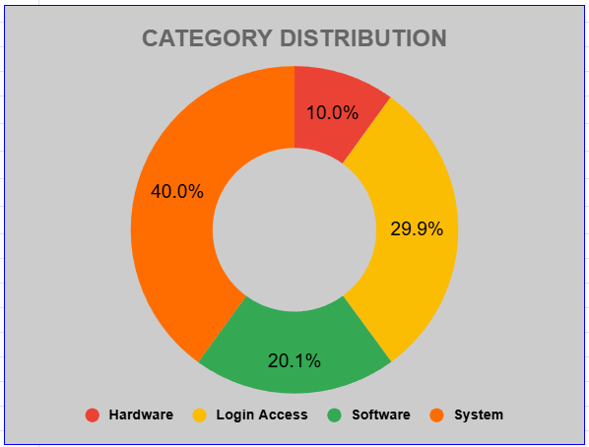
- Description:
Displays the number and percentage of tickets across Hardware, Login Access, Software, and System request categories, helping identify the most common support requests.

Question 5: How many tickets has each agent handled?

Solution:

Final Answer (if any):
The ticket workload is distributed relatively evenly among the IT agents.
- Total Agents: 50
- Total Tickets: 97,498
- Average Tickets Handled per Agent: 1,950 tickets
The highest number of tickets was handled by Aurelio Tanori (2,027 tickets), followed closely by Jesus Contreras (2,026 tickets) and Elena Velez (2,021 tickets).
The lowest number of tickets was handled by Griselda Galindo (1,856 tickets).
Overall, most agents handled between 1,850 and 2,030 tickets, indicating a balanced workload distribution across the support team.

Approach (if any):
A pivot table was created using Agent Name as Rows and Count of Ticket ID as Values. The average tickets handled per agent was calculated by dividing the total number of tickets by the total number of agents. The results were then analyzed to evaluate workload distribution and identify the highest and lowest ticket-handling agents.

Charts & Tables (if any):
- Table / Chart Name:
Top 10 IT Agents by Ticket Handled
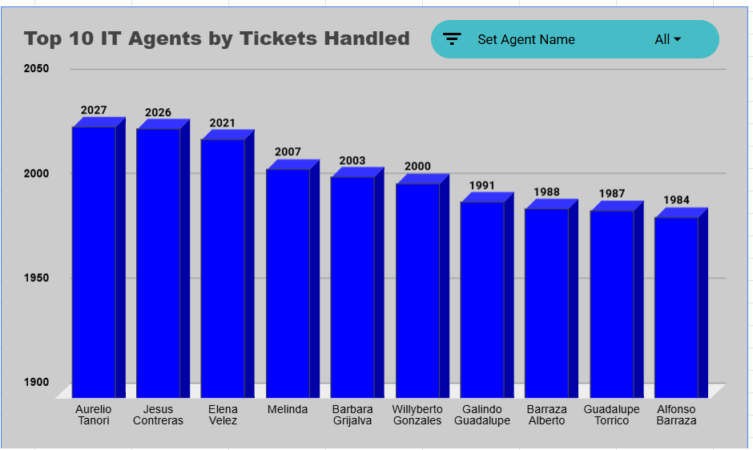
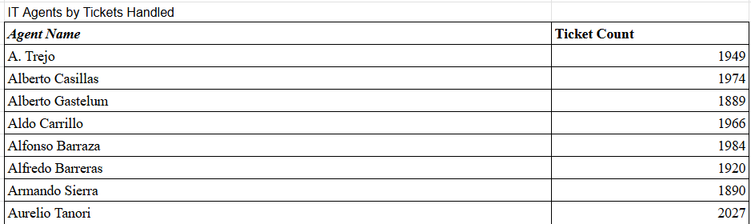
- Description:
The table and chart display the agents who handled the highest number of tickets during the analysis period. This visualization helps assess workload distribution across the IT support team and highlights agents managing the largest ticket volumes.

Question 6: How can you extract the domain from the email addresses in the IT Agents sheet?

Solution:

Final Answer (if any):
The domain and root domain can be extracted from the email addresses using spreadsheet text functions.
Formula Used for Domain Extraction:
=RIGHT(B11,LEN(B11)-FIND("@",B11))
Formula Used for Root Domain Extraction:
=MID(A2,FIND("@",A2)+1,FIND(".",A2,FIND("@",A2))-FIND("@",A2)-1)
Example:
Email Address | Domain | Root Domain
lucero.mata@fp20analytics.com | fp20analytics.com | fp20analytics
elena.velez@fp20analytics.com | fp20analytics.com | fp20analytics

Approach (if any):
The FIND() function was used to locate the position of the "@" symbol within the email address. The RIGHT() function then extracted all characters appearing after the "@" symbol, resulting in the full domain name.

To obtain the root domain, the MID() function was used together with FIND() to extract only the text between the "@" symbol and the first "." occurring after it. This removes the top-level domain extension and returns only the organization name.

This approach demonstrates the use of text manipulation functions for extracting meaningful information from structured email addresses.

Charts & Tables (if any):
- Table / Chart Name:
Email Domain Extraction
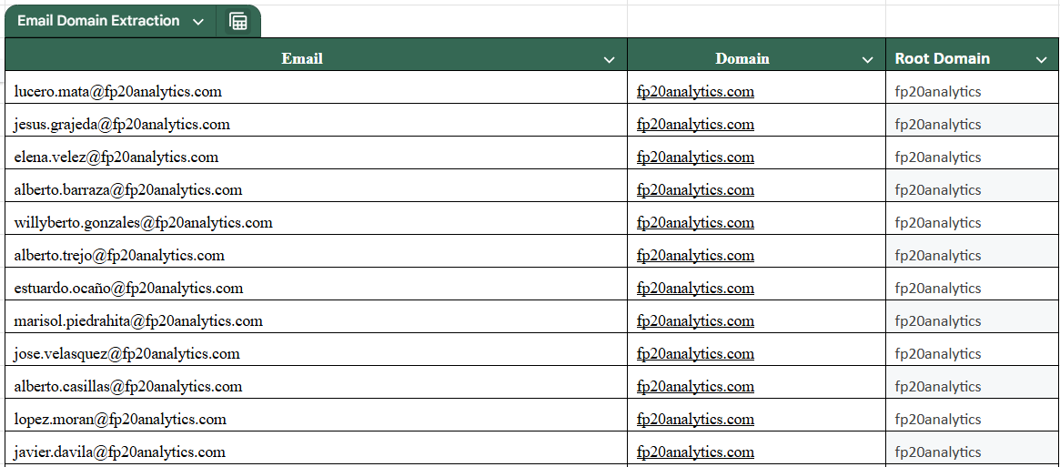
- Description:
The table demonstrates how spreadsheet text functions can be used to extract both the full domain and root domain from IT agent email addresses. This technique is useful for email validation, data standardization, and text-based analysis.

Question 7: How can you find the full name of an agent given their Agent ID?

Solution:

Final Answer (if any):
The full name of an agent can be retrieved using the Agent ID by performing a lookup between the Tickets sheet and the IT Agents sheet.
Formula used:
=VLOOKUP(D2,'IT Agents'!A:B,2,FALSE)

Approach (if any):
A lookup function was used to match the Agent ID from the Tickets sheet with the Agent ID column in the IT Agents sheet. Once a match was found, the corresponding Full Name was returned and stored in the helper column "Agent Name (objective question 7)".
This allowed agent names to be used in further analysis, pivot tables, and dashboard visualizations.

Charts & Tables (if any):

Question 8: What is the count of each issue type (e.g., IT Error, IT Request)?

Solution:

Final Answer (if any):
The distribution of issue types is as follows:

Issue Type Count
IT Request 73,220
IT Error 24,278

Out of 97,498 total tickets, IT Requests account for approximately 75.10% of all tickets, while IT Errors account for approximately 24.90%.

Approach (if any):
A pivot table was created using Issue Type as Rows and Count of Issue Type as Values. The resulting counts were analyzed to understand the distribution of support requests and technical issues within the IT support system.

Charts & Tables (if any):
- Table / Chart Name:
Issue Type Distribution
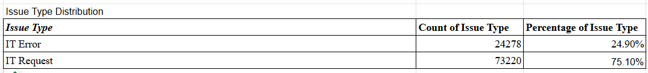

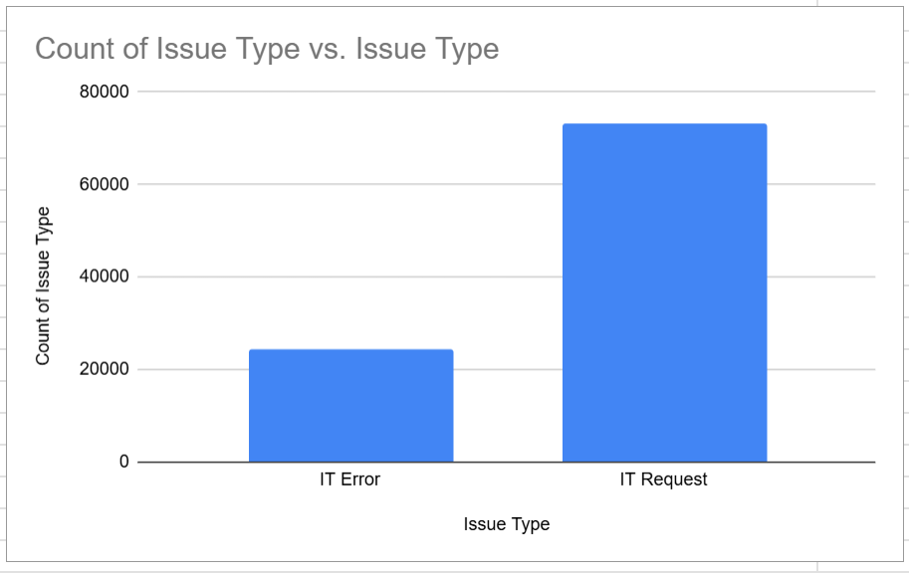
- Description:
Displays the number of tickets categorized as IT Requests and IT Errors, helping identify the overall nature of support activities handled by the IT team.

Question 9: What is the average resolution time for tickets?

Solution:

Final Answer (if any):
Average Resolution Time = 4.55 days

(Actual calculated value: 4.553149808 days)

This indicates that, on average, IT support tickets are resolved within approximately 4.55 days.

Approach (if any):
The average resolution time was calculated using the Resolution Time (Days) field from the Tickets dataset. A pivot table and aggregation functions were used to determine the average number of days required to resolve tickets across the entire dataset.

Charts & Tables (if any):

Question 10: How has the volume of tickets changed over time?

Solution:

Final Answer (if any):
Ticket volume fluctuated over time, showing recurring increases and decreases throughout the analysis period.

The highest ticket volume was recorded in December 2020 with 2,609 tickets.
Other peak periods included:
October 2020 – 2,567 tickets
August 2020 – 2,566 tickets
November 2020 – 2,524 tickets
The lowest ticket volumes occurred between February 2016 and October 2016, ranging from approximately 1,046 to 1,090 tickets.

Overall, the data indicates a general increase in ticket volume over time with periodic fluctuations.

Approach (if any):
A pivot table was created using the ticket date field (Fecha) grouped by Month-Year. The count of Ticket IDs was used to measure ticket volume over time. A trend chart was then created to visualize changes in ticket demand and identify peak and low-volume periods.

Charts & Tables (if any):
- Table / Chart Name:
Volume of Tickets Changed Over Time
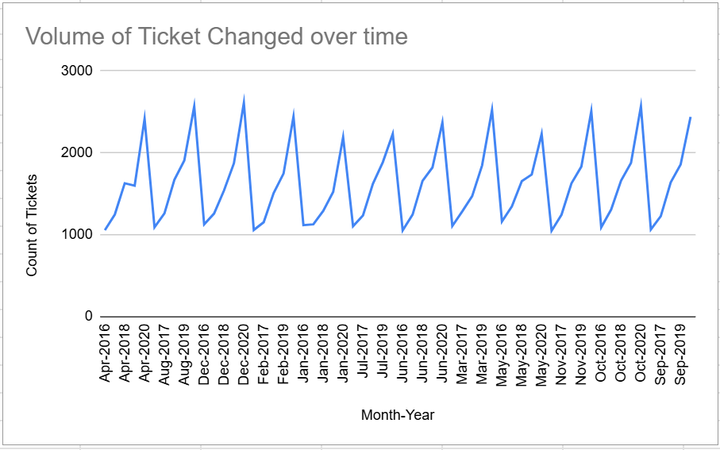
- Description:
Displays ticket volume trends across different time periods and highlights peak and low-demand periods.

Question 11: What is the average age of the IT agents?

Solution:

Final Answer (if any):
Average Age of IT Agents = 40.82 years

This indicates that the IT support workforce consists primarily of experienced professionals with an average age of approximately 41 years.

Approach (if any):
The age of each agent was calculated using the Year of Birth, Month of Birth, and Day of Birth fields available in the IT Agents dataset. The average age was then calculated across all agents to determine the overall workforce age profile.

This analysis helps understand the demographic composition of the support team and provides insight into workforce experience and diversity.

Formula Used:

=AVERAGE(Age)

(where Age was calculated from the birth date fields)

Charts & Tables (if any):
- Table / Chart Name:
Age Distribution of IT Agents

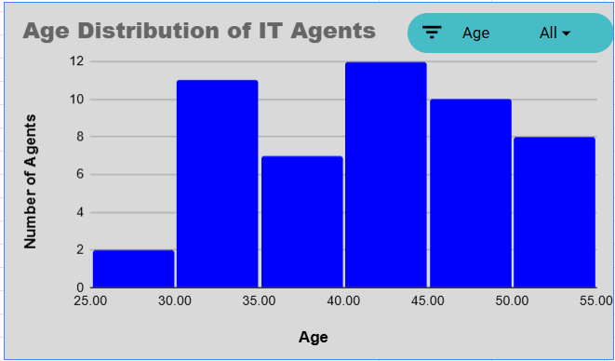

- Description:
Displays the distribution of agent ages across the IT support team and helps evaluate the workforce demographic profile. The visualization highlights how agents are distributed across different age groups and supports understanding of the team's overall experience level.

Question 12: Is there a correlation between the severity of issues and the resolution time?

Solution:

Final Answer (if any):
No, there is no strong positive correlation between severity and resolution time.

The highest average resolution time occurs at Severity Level 2 (4.66 days), while Severity Level 4 has one of the lowest average resolution times (2.00 days). This indicates that higher severity does not necessarily result in longer resolution times.

The findings suggest that factors such as ticket prioritization, escalation procedures, and resource allocation may influence resolution performance more strongly than severity level alone.

Approach (if any):
A pivot table was created using Severity Level as Rows and Average Resolution Time (Days) as Values. The resulting averages were compared across severity levels to determine whether resolution time increased consistently as severity increased.

This analysis was performed to evaluate the relationship between ticket severity and operational response performance.

Charts & Tables (if any):
- Table / Chart Name:
Average Resolution Time by Severity Level
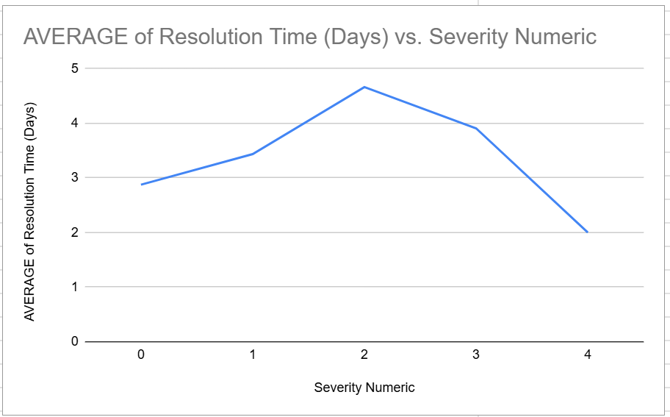

- Description:
Displays the average resolution time associated with each severity level and helps evaluate the relationship between ticket severity and resolution performance.

Question 13: How many categorical columns are there in the data? [Search about categorical and continuous data, and try to answer this question]

Solution:

Final Answer (if any):
There are 7 categorical columns in the dataset.
The categorical columns are:
- ID Ticket
- Employee ID
- Agent ID
- Request Category
- Issue Type
- Severity
- Priority
These columns represent categories, labels, or identifiers rather than continuous numerical measurements.

Approach (if any):
The dataset columns were classified into categorical, numerical, and date-based fields. Categorical columns were identified as those containing labels, classifications, or identifiers used for grouping and segmentation rather than mathematical calculations.

Charts & Tables (if any):

SUBJECTIVE QUESTIONS

Question 1: If there is an investment, should it be used to hire more IT agents, improve training programs, or upgrade ticket management software?

Analysis: Perform a cost-benefit analysis using ticket resolution and satisfaction metrics.

Solution:

Approach:
A cost-benefit analysis was performed using ticket resolution time, workload distribution, and employee satisfaction metrics. Average resolution times across request categories were analyzed to identify operational bottlenecks, while ticket distribution among agents was reviewed to determine whether staffing shortages existed.

Charts & Tables:
- Table / Chart Name:
Average Resolution Time by Request Category
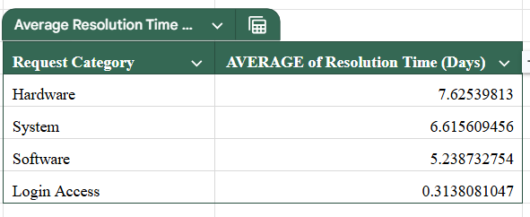
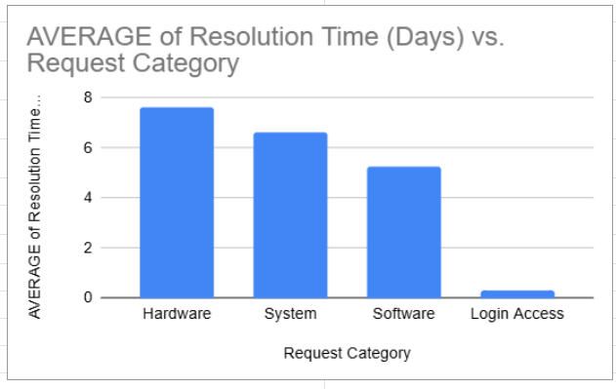
- Description:
Displays the average employee satisfaction score across request categories and helps evaluate whether longer resolution times negatively impact service quality.

Insights:
- Hardware requests have the highest average resolution time (7.63 days), followed by System requests (6.62 days).
- Login Access requests are resolved very quickly (0.31 days), indicating that existing workflows for routine issues are highly efficient.
- Employee satisfaction remains consistently high across request categories (approximately 4.1/5).
- Ticket workload is distributed relatively evenly among agents, suggesting that staffing capacity is sufficient and that workload imbalance is not a major concern.
- The primary opportunity for improvement lies in reducing resolution times for technically complex request categories rather than increasing workforce size.

Recommendations:
- Prioritize investment in technical training programs to improve agent efficiency when handling Hardware and System-related issues.
- Upgrade ticket management software and automation capabilities to reduce resolution delays and improve workflow efficiency.
- Implement advanced routing, categorization, and diagnostic tools to accelerate issue resolution.
- Continue monitoring workload distribution, but avoid increasing staffing levels unless ticket volume grows significantly beyond current levels.

Question 2: Which agents need additional training based on their performance metrics?

Analysis: Identify agents with the lowest satisfaction ratings and longest resolution times.

Solution:

Approach:
Agent performance was analyzed using average satisfaction ratings and average resolution times. Pivot tables and charts were used to compare agent efficiency and identify agents requiring additional support or technical training.

Charts & Tables:
- Table Name:
Agent Performance Analysis
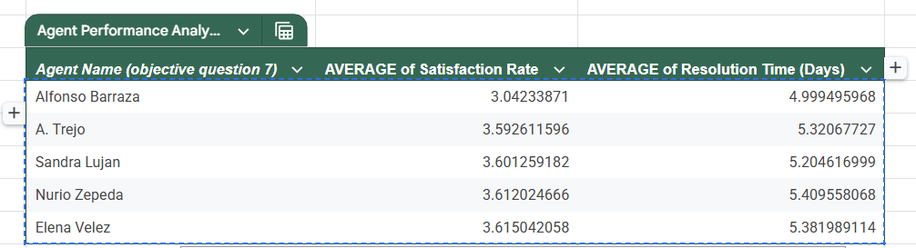
- Chart Name:
AVERAGE of Satisfaction Rate and AVERAGE of Resolution Time (Days)
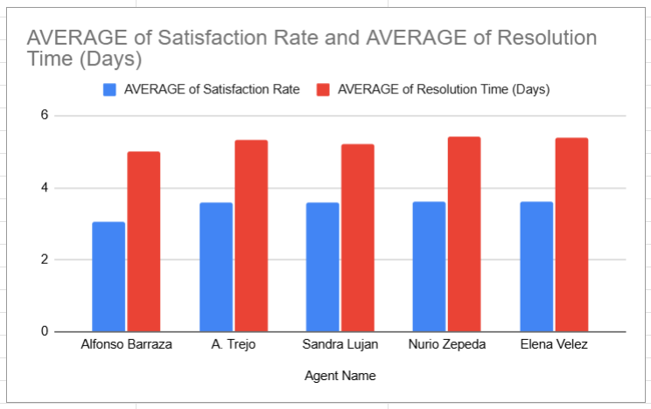
- Description:
Displays average satisfaction scores and average resolution times for each IT agent.

Insights:
- Alfonso Barraza has the lowest average satisfaction score at approximately 3.04.
- A. Trejo, Nurio Zepeda, and Elena Velez also show relatively lower satisfaction ratings compared to other agents.
- Resolution times for these agents remain close to the team average, ranging between 5.0 and 5.4 days.
- Overall, most agents maintain satisfaction scores above 3.5, indicating generally stable team performance.

Recommendations:
- Provide targeted coaching and communication training for agents with lower satisfaction ratings.
- Conduct periodic performance reviews and mentoring sessions.
- Share best practices among agents to improve customer interaction quality and ticket resolution efficiency.

Question 3: Do certain categories of requests have longer resolution times?

Analysis: Analyze the resolution times by request category.

Solution:

Approach:
The analysis was performed by calculating the average resolution time for each request category using pivot tables and charts. A quarter-wise comparison was also conducted to determine whether category performance remained consistent over time.

The results were analyzed to identify request categories experiencing longer resolution times and potential operational bottlenecks.

Charts & Tables:
- Table Name:
Average Resolution Time by Request Category
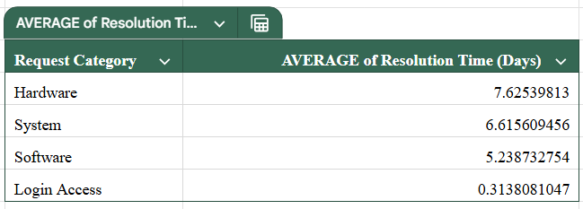
- Chart Name:
Average Resolution Time by Request Category
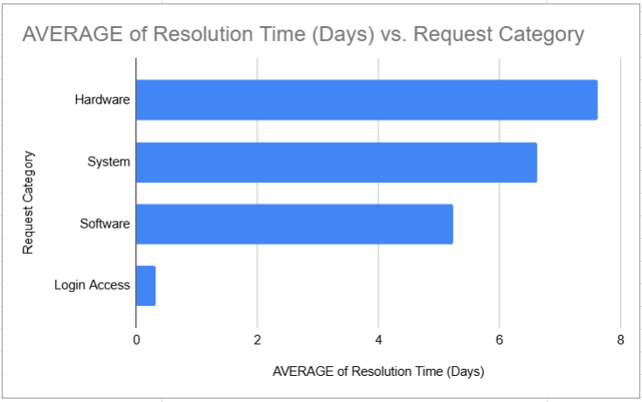
- Table Name:
Average Resolution Time by Request Category (Quarter-wise)
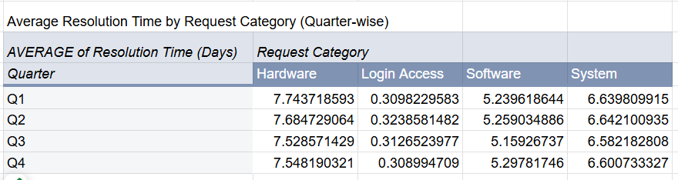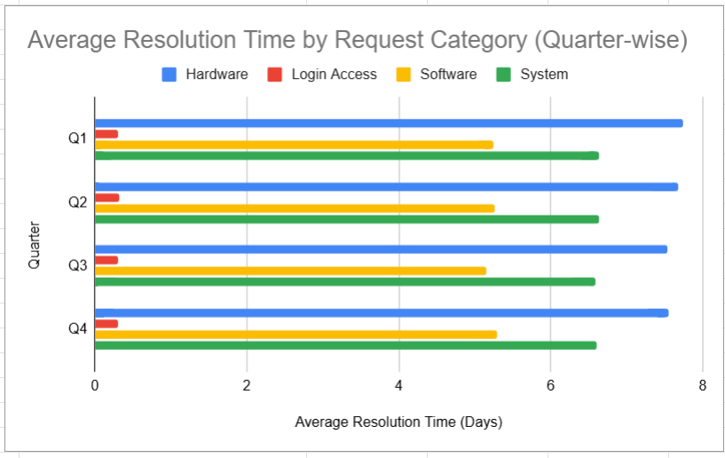
- Description:
Displays the average resolution time for Hardware, System, Software, and Login Access requests. The quarter-wise analysis provides additional visibility into whether resolution performance remains stable throughout the year.

Insights:
- Hardware requests have the highest average resolution time at approximately 7.63 days, making them the most time-consuming category.
- System requests require approximately 6.62 days on average and represent the second most complex category.
- Software requests have moderate resolution times at approximately 5.24 days.
- Login Access requests are resolved very quickly at approximately 0.31 days, indicating highly efficient handling processes.
- Quarter-wise analysis shows similar resolution patterns across all quarters, suggesting that these delays are driven by request complexity rather than seasonal factors.
- Hardware and System requests consistently remain above the overall average resolution time of 4.55 days.

Recommendations:
- Provide additional technical training and specialized resources for Hardware and System issue resolution.
- Improve workflow automation, diagnostic tools, and knowledge-base support for complex technical requests.
- Investigate recurring causes of Hardware and System delays to reduce resolution time.
- Continue maintaining the efficient processes currently used for Login Access requests, as they demonstrate strong operational performance.

Question 4: How effective are the current software tools in managing IT tickets?

Analysis: Evaluate performance metrics before and after the implementation of new tools.

Solution:

Approach:
The effectiveness of the current ticket management tools was evaluated using employee satisfaction scores, average resolution times, and severity-based ticket performance metrics. Resolution efficiency across severity levels was analyzed to determine whether prioritization and escalation workflows were functioning effectively.

The relationship between ticket severity and priority assignment was also reviewed to validate whether critical issues were receiving appropriate attention and resource allocation.

Charts & Tables:
- Chart Name:

Table / Chart Name:
Average Resolution Time by Severity Level
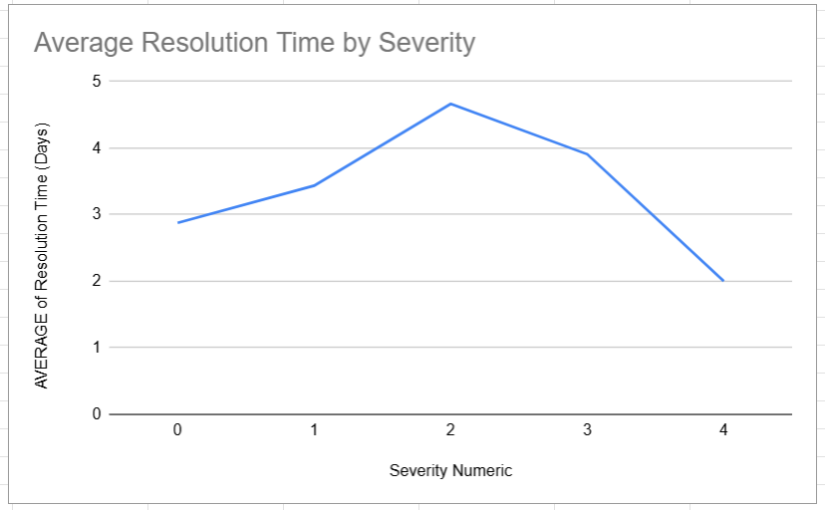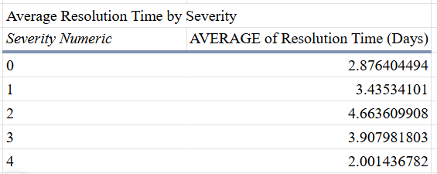

Table / Chart Name:
Distribution of Tickets by Resolution Time
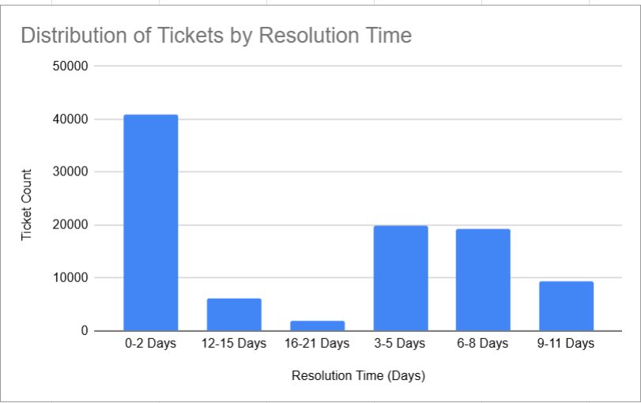
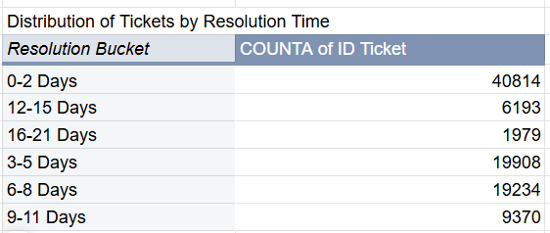
Table / Chart Name:
Severity vs Priority Distribution
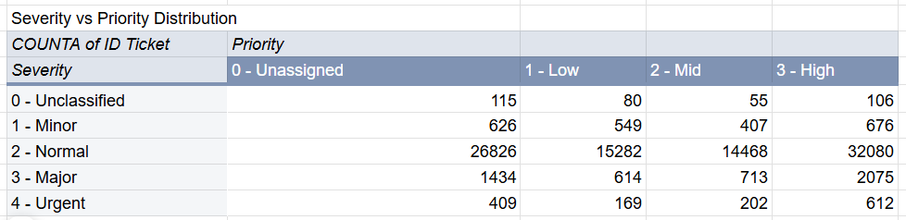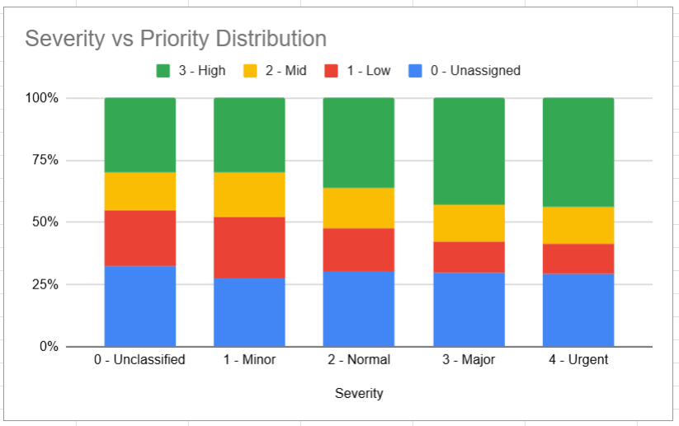
- Description:
These visualizations evaluate operational performance by showing how resolution times vary across severity levels and how tickets are distributed across priority categories. Together, they help assess whether the ticket management system is effectively prioritizing and resolving support requests.

Insights:
- The average employee satisfaction score remains relatively high at approximately 4.10/5, indicating generally positive user experiences.
- The average ticket resolution time is approximately 4.55 days, demonstrating moderate operational efficiency.
- Severity Level 4 tickets are resolved in approximately 2.00 days, while Severity Level 2 tickets require approximately 4.66 days on average.
- The Severity vs Priority analysis shows that higher-severity tickets are primarily assigned to higher-priority categories, indicating that escalation and prioritization processes are functioning as intended.
- The majority of tickets belong to the mid-priority category, representing the largest operational workload handled by the support team.
- The results suggest that the current software tools support effective ticket prioritization, although additional improvements could further reduce resolution times for complex requests.

Recommendations:
- Continue improving automation and ticket routing for complex categories such as Hardware and System requests.
- Upgrade monitoring, diagnostic, and workflow management tools to reduce resolution delays.
- Maintain the existing prioritization and escalation framework, as high-severity tickets are being routed and resolved effectively.
- Regularly review severity classifications and priority assignment rules to ensure continued alignment with business requirements.

Question 5: How has the performance of the IT support team changed over time (e.g., monthly or quarterly)?

Analysis: Trend analysis using time series charts.

Solution:

Approach:
time-series analysis was performed using ticket volume, employee satisfaction, and average resolution time trends across different Month-Year periods. Pivot tables and charts were used to evaluate changes in workload, service quality, and operational efficiency over time.

The analysis compared ticket demand with resolution performance and satisfaction metrics to determine whether the IT support team maintained consistent performance during periods of varying workload.

Charts & Tables:
- Table / Chart Name:
Ticket Volume Trend
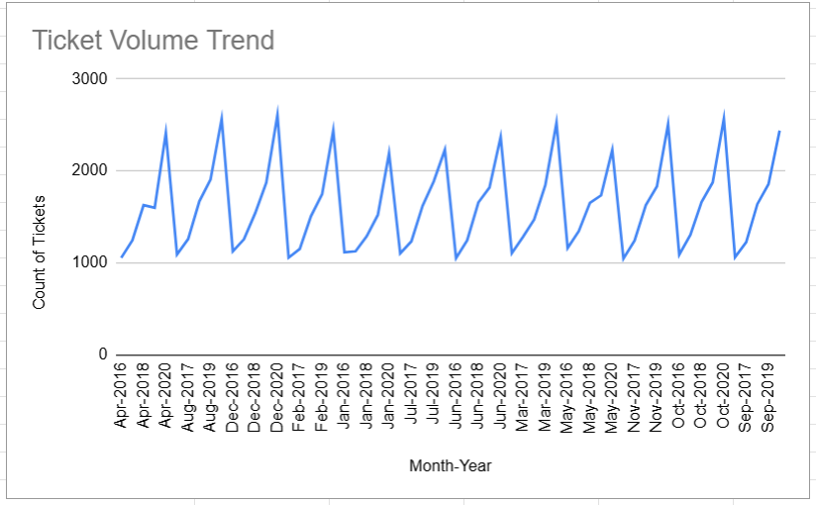
- Table / Chart Name:
Average Satisfaction Rate Over Time
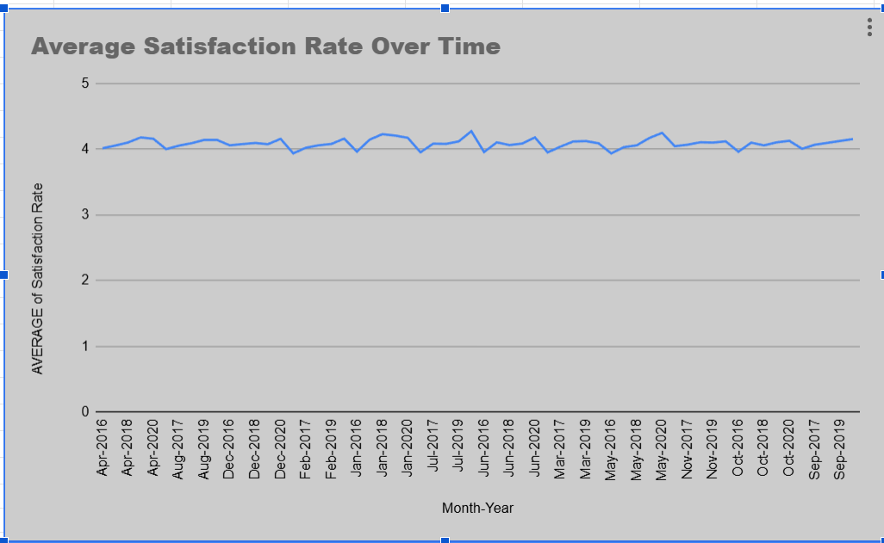

- Table / Chart Name:
AVERAGE of Resolution Time (Days) vs. Month-Year
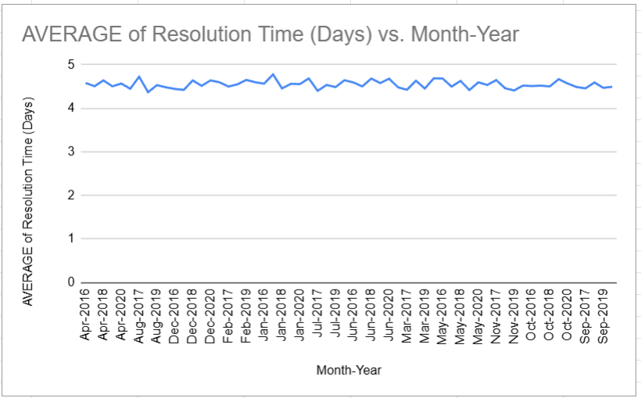
- Description:
These visualizations display changes in ticket volume, employee satisfaction, and average resolution time over different time periods. Together, they help evaluate workload trends, service quality, and operational consistency across the analysis period.

Insights:
- Ticket volume shows recurring cyclical peaks and declines throughout the analysis period, indicating predictable workload patterns.
- Employee satisfaction remains relatively stable over time, generally maintaining values around 4.0–4.2, despite fluctuations in ticket demand.
- Average resolution times remain broadly consistent across months, suggesting stable operational efficiency.
- Periods of higher ticket volume do not result in major declines in satisfaction or significant increases in resolution time.
- The combination of stable satisfaction scores and relatively consistent resolution times indicates that the IT support team has effectively managed changing workload demands.

Recommendations:
- Maintain current operational processes and staffing levels during normal workload periods.
- Use historical ticket trends to forecast recurring peak periods and improve workforce planning.
- Continue monitoring ticket volume, satisfaction, and resolution time together to identify performance changes early.
- Implement additional automation and workflow improvements to further strengthen performance during high-demand periods.

Question 6: If we invest more on tech (Hardware, software, etc), do you think it will improve the ticket resolution times and employee satisfaction?

Analysis: Use historical data to project potential improvements.

Solution:

Approach:
The analysis was performed using historical ticket resolution times, employee satisfaction scores, request category performance, and ticket severity distribution. Categories with longer resolution times were examined to determine whether operational delays were caused by technical complexity, process limitations, or staffing constraints.

Employee satisfaction metrics were also reviewed to evaluate whether service quality remained stable despite longer resolution times in certain request categories.

Charts & Tables:
- Table / Chart Name:
Average Resolution Time by Request Category
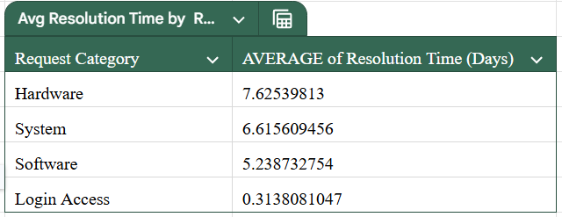
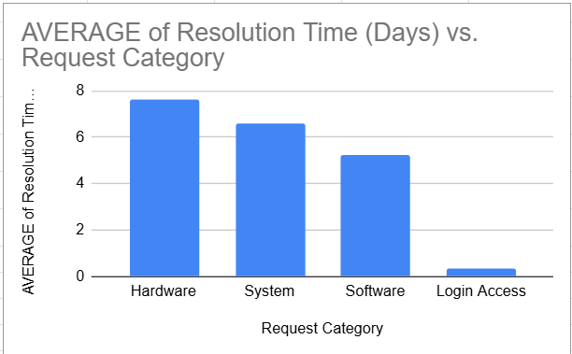
- Table / Chart Name:
Average Satisfaction Rate by Request Category
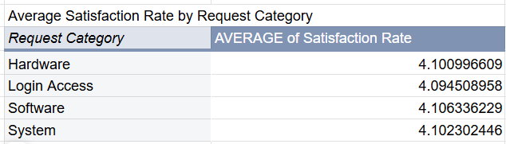
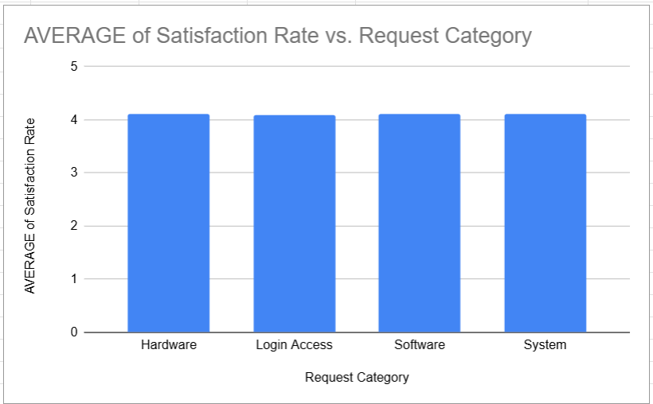
- Table / Chart Name:
Ticket Distribution by Severity
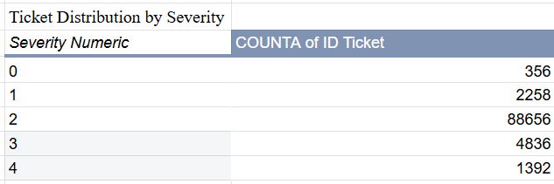
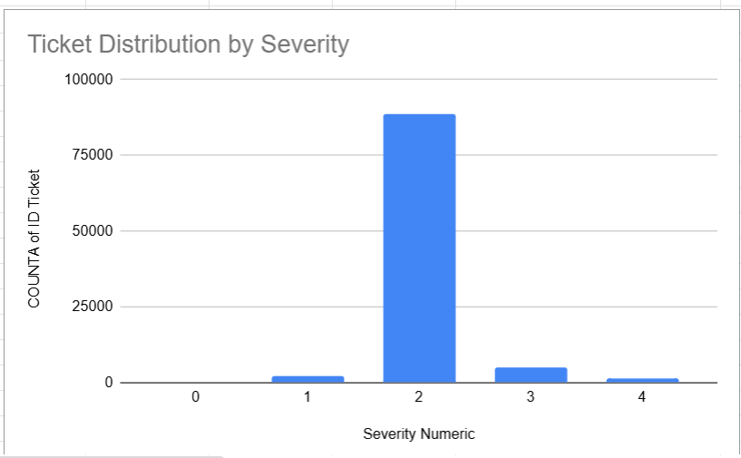
- Table / Chart Name:
Average Resolution Time by Severity
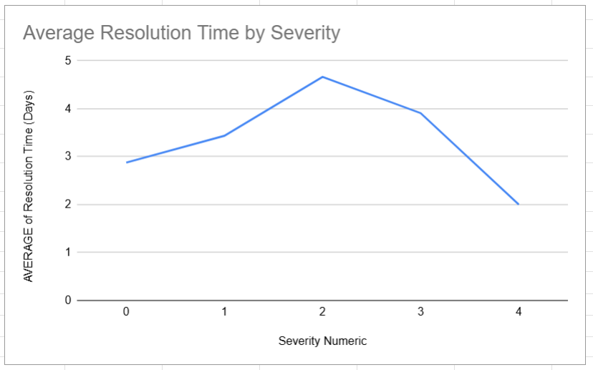

- Description:
These tables and charts compare ticket resolution performance, employee satisfaction, and ticket severity distribution. Together, they help identify operational bottlenecks and assess whether technology investments could improve efficiency and service quality.

Insights:
- Hardware requests have the highest average resolution time (7.63 days), followed by System requests (6.62 days).
- Software requests require approximately 5.24 days on average, while Login Access requests are resolved very quickly (0.31 days).
- Employee satisfaction remains consistently high across request categories, averaging approximately 4.10/5.
- The majority of tickets belong to the mid-severity category, indicating that most operational workload is concentrated in moderately complex support issues.
- Most agents maintain stable satisfaction and performance levels, suggesting that delays are more closely related to technical complexity and process limitations than workforce shortages.
- Hardware and System requests present the greatest opportunity for improvement through technology investments and automation.

Recommendations:
- Invest in improved diagnostic tools, automation systems, and ticket management software to reduce resolution times for complex requests.
- Upgrade technical infrastructure and support tools used for Hardware and System issue resolution.
- Implement smarter ticket routing and knowledge-base solutions to improve resolution efficiency.
- Provide targeted technical training for agents handling complex support categories.
- Continue monitoring satisfaction scores and resolution metrics after technology improvements to measure their impact.

Question 7: What are the key performance metrics for IT agents, and how can they be improved, do we need to fire any agents?

Analysis: Define and analyze metrics such as average handling time, satisfaction scores, and number of tickets resolved.

Solution:

Approach:
The analysis was conducted using key performance indicators (KPIs), including total tickets handled, average resolution time, average satisfaction score, and top-performing agent metrics. Agent workload distribution and satisfaction ratings were also reviewed to identify performance gaps and opportunities for improvement.

The objective was to evaluate overall team effectiveness, identify agents requiring additional support, and determine whether workforce reductions were justified based on performance data.

Charts & Tables:

Chart name:
Top 10 IT Agents by Tickets Handled
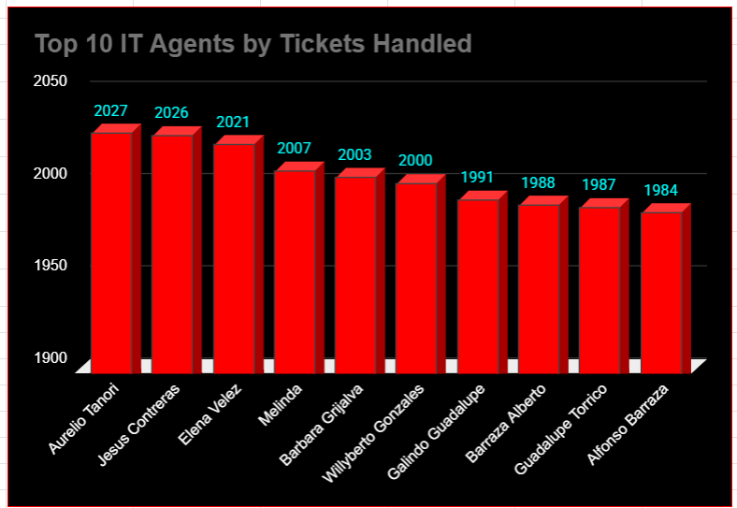

Table Name:
Lowest Performing Agents

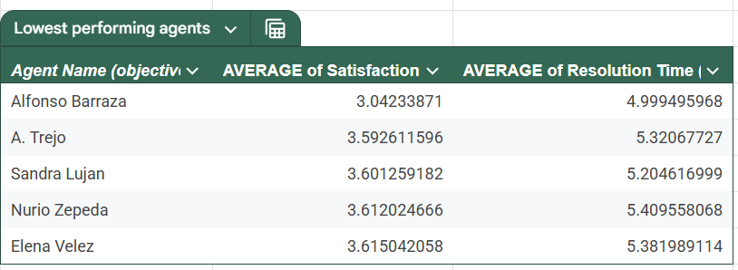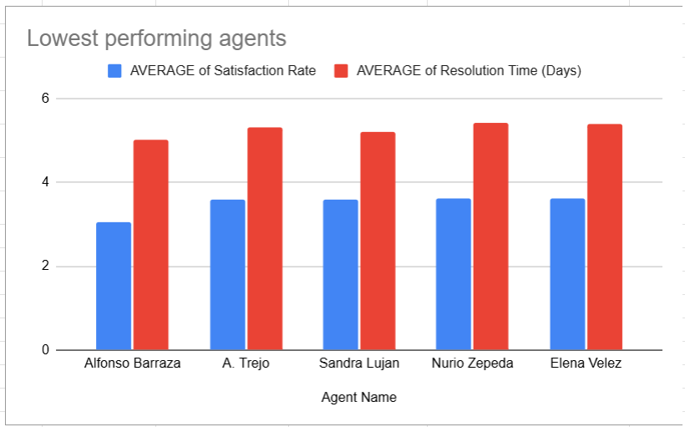

KPI Metrics:
Total Tickets
Average Resolution Time
Top Performer
Average Satisfaction

- Description:
These visualizations and KPI metrics provide a comprehensive view of agent performance by measuring workload, service quality, and operational efficiency. The analysis highlights both high-performing agents and agents who may benefit from additional coaching or training.

Insights:
- The support team processed 97,498 total tickets, demonstrating substantial operational capacity.
- The overall average resolution time is approximately 4.55 days, indicating stable ticket-handling performance.
- The average employee satisfaction score remains high at approximately 4.10/5, reflecting generally positive service quality.
- Workload distribution among agents is relatively balanced, with most agents handling similar ticket volumes.
- The Lowest Performing Agents table identifies a small group of agents with comparatively lower satisfaction scores.
- While a few agents require improvement, overall team performance remains stable and effective.

Recommendations:
- Provide targeted coaching, mentoring, and communication training for agents with lower satisfaction scores.
- Continue monitoring key performance metrics through regular KPI reviews.
- Encourage knowledge-sharing and best-practice adoption from top-performing agents.
- Implement performance improvement plans where necessary before considering workforce reductions.
- Large-scale firing is not recommended, as the majority of agents demonstrate acceptable performance levels and workload distribution remains balanced.

Question 8: How do employee demographics (e.g., department, seniority) impact satisfaction and ticket outcomes?

Analysis: Segment analysis using filters and pivot tables.

Solution:

Approach:
The analysis was conducted using the available demographic information, primarily agent age, together with employee satisfaction metrics. Agents were grouped into age categories and their average satisfaction scores were compared using pivot tables and charts.

Since the dataset does not contain department, seniority, tenure, or job-level information, the analysis was limited to age-based demographic segmentation.

Charts & Tables:
- Table / Chart Name:
Age Distribution of IT Agents

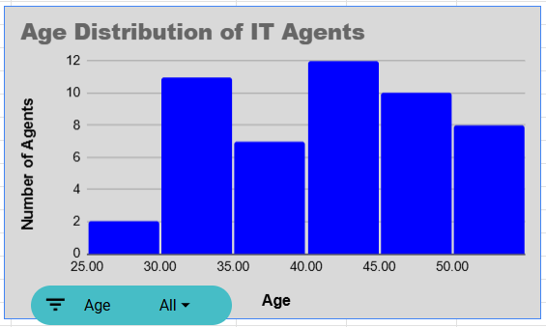
- Table / Chart Name:
Average Satisfaction Rate by Age Group
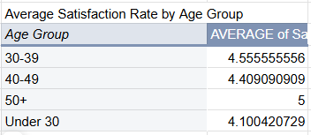
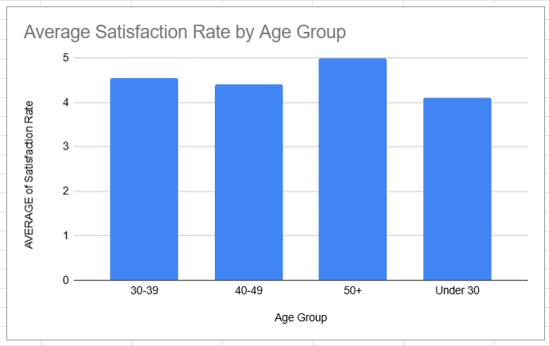

- Description:
These visualizations display the distribution of agents across different age groups and compare average satisfaction scores by age category. The analysis helps evaluate whether age has a measurable impact on employee satisfaction and support outcomes.

Insights:
- The average age of IT agents is approximately 40.82 years.
- The workforce is distributed across multiple age groups, indicating a balanced mix of experience levels.
- Average satisfaction scores remain relatively consistent across age groups, with only minor variations observed.
- No age group demonstrates significantly higher or lower satisfaction levels compared to the others.
- The results suggest that age has limited impact on employee satisfaction and overall support performance.
- Additional demographic attributes such as department, seniority, and tenure are not available in the dataset, limiting further segmentation analysis.

Recommendations:
- Continue maintaining a balanced workforce across different age groups.
- Provide training and professional development opportunities to employees regardless of age category.
- Monitor satisfaction trends periodically to identify any emerging demographic patterns.
- Expand future datasets with additional demographic variables such as department, seniority, tenure, and job level to enable deeper workforce analysis.

Question 9: Identify the trends for IT support operations based on ticket volumes and satisfaction, and mention the peak and stable times?

Analysis: Use pivot tables and charts to identify peak and off-peak hours.

Solution:

Approach:
A trend analysis was performed using ticket volume and employee satisfaction metrics over time. Pivot tables and charts were used to identify recurring workload patterns, peak operational periods, and stable performance periods.

The relationship between ticket demand and satisfaction levels was also evaluated to determine whether increased workloads affected service quality.

Charts & Tables:
- Table / Chart Name:
Ticket Volume and Satisfaction Trend
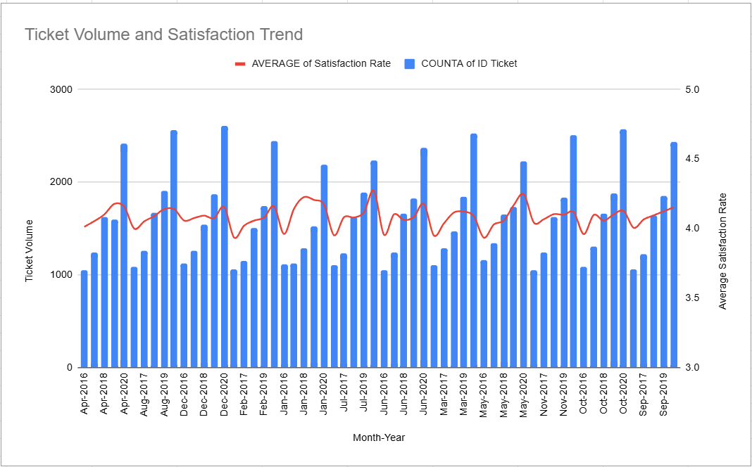
- Table / Chart Name:
Distribution of Tickets by Satisfaction Score
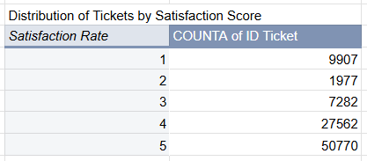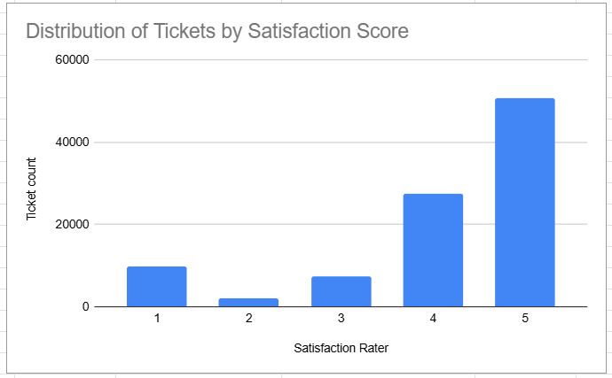
- Description:
These visualizations display changes in ticket volume and employee satisfaction over time, while also showing the distribution of satisfaction scores across all tickets. Together, they help identify peak operational periods, stable service periods, and overall service quality trends.

Insights:
- December 2020 recorded the highest ticket volume with approximately 2,609 tickets.
- Other major peak periods included:
- October 2020 – 2,567 tickets
- August 2020 – 2,566 tickets
- November 2020 – 2,524 tickets
- The lowest ticket volumes occurred between 2016 and early 2017, ranging from approximately 1,046 to 1,090 tickets.
- Ticket volume exhibits recurring cyclical peaks and declines throughout the analysis period.
- Employee satisfaction remained relatively stable despite fluctuations in ticket demand, indicating consistent service quality.
- The satisfaction score distribution shows that the majority of tickets received favorable satisfaction ratings, supporting the conclusion that operational performance remained stable even during peak workload periods.

Recommendations:
- Allocate additional resources and monitoring during recurring peak periods.
- Continue tracking satisfaction alongside ticket volume to ensure service quality remains stable during high-demand periods.
- Use historical ticket trends for workforce planning and workload forecasting.
- Consider automation and proactive support measures to improve operational efficiency during peak periods.
- Regularly review satisfaction trends to identify potential service quality issues before they affect overall performance.

Question 10: What metrics should be included in the final dashboard to provide a comprehensive view of call center performance and guide investment decisions?

Solution:

Approach:
The final dashboard was designed to provide a comprehensive view of IT support operations by combining workload, service quality, operational efficiency, workforce performance, and demographic metrics.

KPI cards were used to provide high-level performance summaries, while charts were used to visualize trends, distributions, and operational patterns. The selected metrics help management identify improvement opportunities, monitor performance, and make informed decisions regarding staffing, training, and technology investments.

Charts & Tables:
KPI Card:

Total Tickets

Description:
Displays the total number of tickets processed and provides an overview of operational workload.

KPI Card:

Average Resolution Time

Description:
Shows the average number of days required to resolve support tickets and measures operational efficiency.

KPI Card:

Average Satisfaction

Description:
Measures overall employee satisfaction with IT support services and reflects service quality.

KPI Card:

Top Performer

Description:
Identifies the highest-performing IT agent based on ticket handling performance and service quality metrics.

KPI Card:

Total Agents

Description:
Displays the total number of IT support agents available to handle operational workload.
Chart Name:

Volume of Tickets Changed Over Time

Description:
Displays ticket demand trends across different time periods and highlights peak and low-volume periods.

Chart Name:

Top 10 IT Agents by Tickets Handled

Description:
Highlights the agents handling the highest ticket volumes and helps evaluate workload distribution.

Chart Name:

Average Satisfaction Rate Over Time

Description:
Shows changes in employee satisfaction across different periods and helps monitor service quality trends.

Chart Name:

Average Resolution Time by Request Category (Quarter-wise)

Description:
Compares resolution times across request categories and quarters to identify operational bottlenecks and improvement opportunities.

Chart Name:

Average Satisfaction Rate by Age Group

Description:
Evaluates satisfaction trends across different age groups and supports workforce demographic analysis.

Chart Name:

Category Distribution

Description:
Displays the distribution of tickets across Hardware, Login Access, Software, and System request categories.

Chart Name:

Ticket Distribution by Severity

Description:
Shows the distribution of tickets across severity levels and helps assess workload complexity.

Chart Name:

Distribution of Tickets by Satisfaction Score

Description:
Displays the spread of satisfaction ratings and helps evaluate overall service quality.

Chart Name:

Distribution of Tickets by Resolution Time

Description:
Illustrates how ticket resolution times are distributed and helps identify delays or inefficiencies.

Chart Name:

Age Distribution of IT Agents

Description:
Displays the workforce age profile and supports demographic analysis.

Chart Name:

Average Resolution Time by Severity Level

Description:
Shows how resolution time varies across severity levels and helps evaluate prioritization effectiveness.
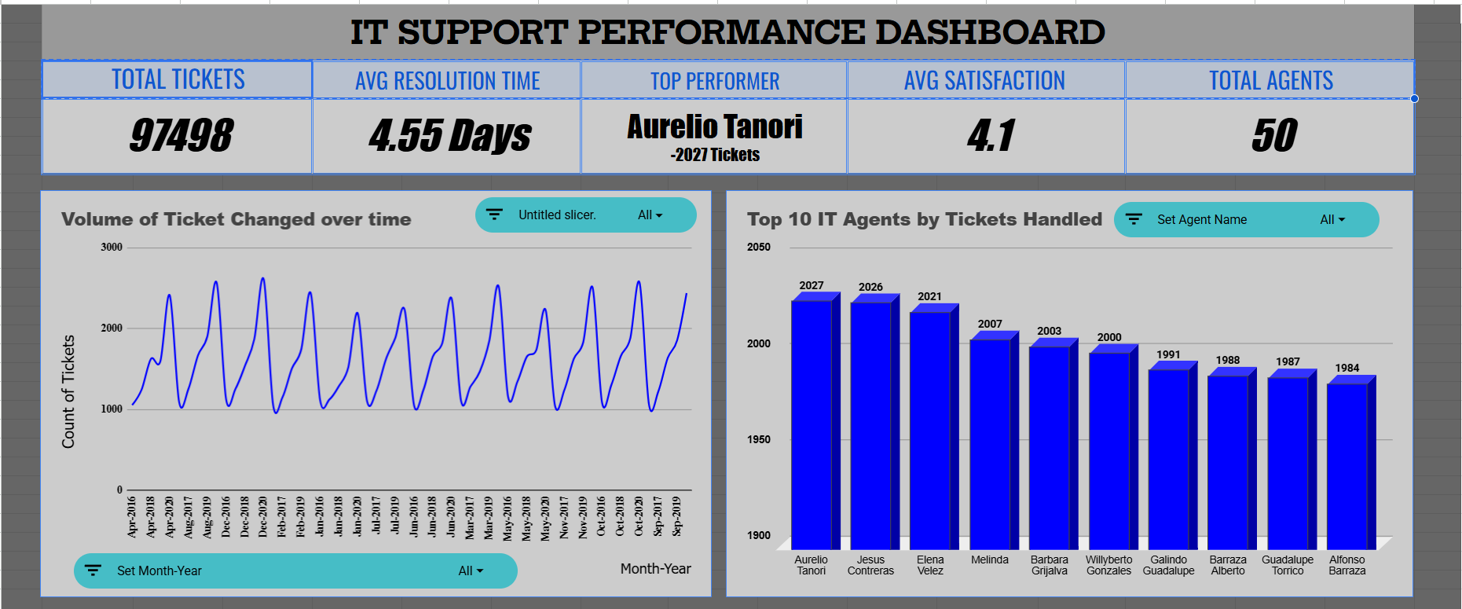
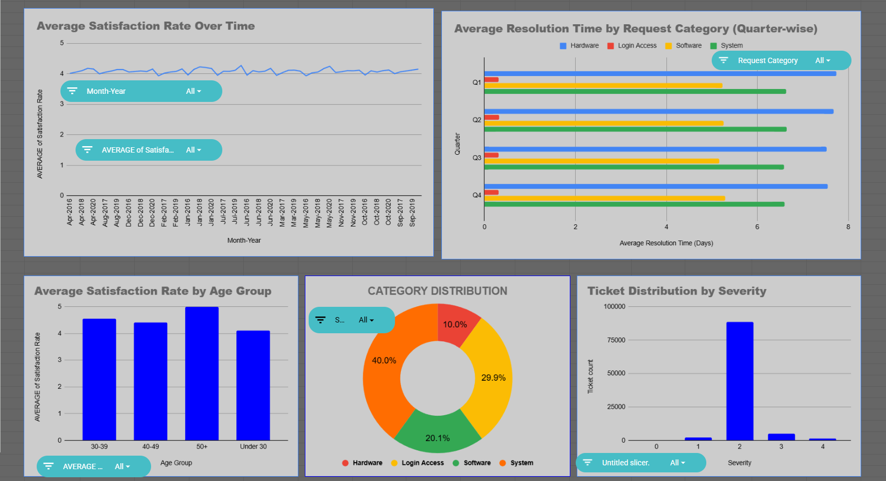
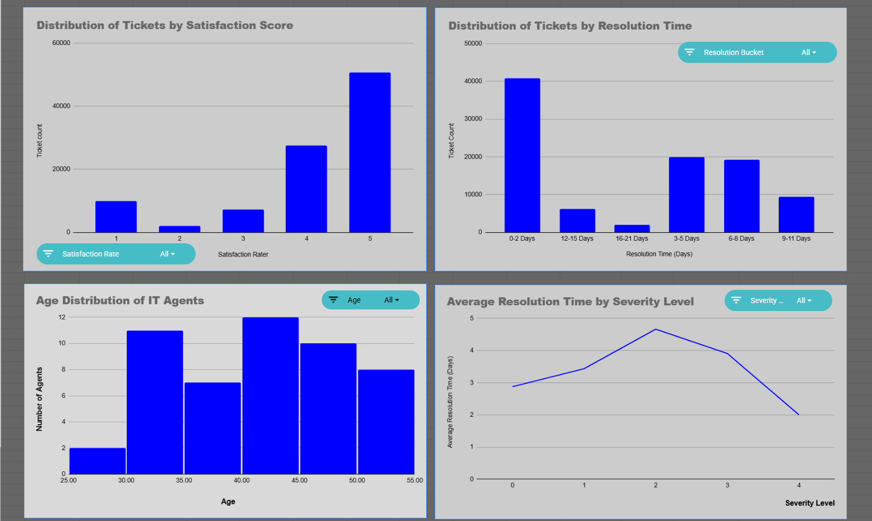
Description: Consolidated view of all KPIs and charts used for management decision-making.

Insights:
- Ticket volume metrics provide visibility into operational demand and workload trends.
- Satisfaction metrics indicate that overall service quality remains consistently strong.
- Resolution time analysis helps identify categories and processes that require operational improvement.
- Category and severity distributions provide insight into the types and complexity of support requests handled by the team.
- Agent performance metrics support workload balancing, coaching, and performance management initiatives.
- Demographic metrics help monitor workforce composition and satisfaction across different age groups.
- Time-series trends enable management to identify peak periods and plan resources proactively.
- The combination of operational, performance, and satisfaction metrics provides a well-rounded view of IT support effectiveness..

Recommendations:
- Continue monitoring ticket volume, satisfaction, and resolution time as primary operational KPIs.
- Use category-level resolution metrics to identify areas where technology investments can reduce delays.
- Focus training and coaching efforts on categories and agents requiring performance improvement.
- Monitor workload and severity trends to improve resource allocation and workforce planning.
- Maintain regular reviews of dashboard metrics to support continuous operational improvement.
- Expand future dashboards with additional KPIs such as First Response Time, Escalation Rate, Reopened Ticket Rate, and SLA Compliance if the data becomes available.

